**Background**  
[Who is the project for? Describe an opportunity or problem that the project is to address.]

This project would be for my father and his work. He works at the City of Kirkwood Water Department. The problem is the lack of communication between the Kirkwood residents and the water department. For Kirkwood residents it's difficult to report problems/main breaks to the city. This app would address how the residents communicate with the water department.

**Benefits**

[What benefits will this project provide to the target audience? Explain how your app will improve the lives of your users. Do not list features in this section!]

The target audience (Kirkwood residents) will benefit from the increased amount of communication and response time between them and the Water department. Project would make communication between the Kirkwood residents and the water department easier. This app will allow users to remotely contact the water department about a water main break instead of having to call a representative to then pass the information on. This app will allow user to quickly and efficiently tell the location of a break making unsocial people's life's way easier and just clicking a few buttons compared to talking to a person and describing the situation.

**Key Features**

[List 3-5 the key features in a list /functionality that your app will provide to users]

* ***[Create/Read/Update/Delete Records in a database]***
* Residents may ***Create*** or submit a “Break” ticket that will be sent to a database the employees can see.
* Residents and logged in Employees can ***Read*** the tickets submitted from other residents.
* Residents and Logged in Employees can ***Update*** the tickets within the database with new information in the event something incorrect was inputted.
* Logged in Employees can ***Delete*** tickets once they have been “Fixed”.

**Comparison with similar apps**

[Research Apps that exist and perform the same or similar functions. List 3 pieces of software that are similar]

* <https://kirkwoodmo.citysourced.com/servicerequests/create>
* <https://secure.coplogic.com/dors/en/filing/submitreport?dynparam=1680036045644>
* <https://downdetector.com/>

[Are there similar apps that would that offer the same features? How will your app be different?]

Sadly, there is an actual website that I didn’t know existed where someone can go onto to report a main break at and other problems in Kirkwood. It had similar features of reporting the problem and a map (so much more advanced than I know how to make). What I would do differently is add some more features and focus specifically on the city of Kirkwood water department. The user would be able to report more in depth about the break if they would like to and add a phone number if they chose to be “called” if needed. Users could also get a “live” report of the crew and what's happening at that time. I was also thinking about a timer feature to display the estimated time till completion so the user can see the live progress.

**Design Ideas**

[Research what you would like your app to look like. Find inspiration from other apps/websites. What color scheme as well as overall look and feel?]

White background with light blue buttons or features to follow the color scheme of water. Probably similar to the actual Kirkwood website but different colors and possibly more buttons and form refreshes to display new information. Add a timer/progress bar to update or show the progress of which the main is being fixed. Pictures of water related things like hydrants or water to be shown with corresponding things.

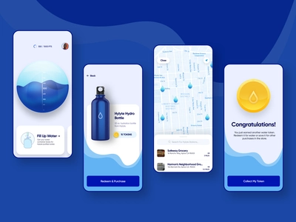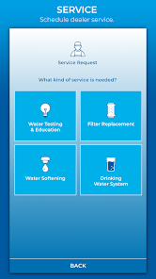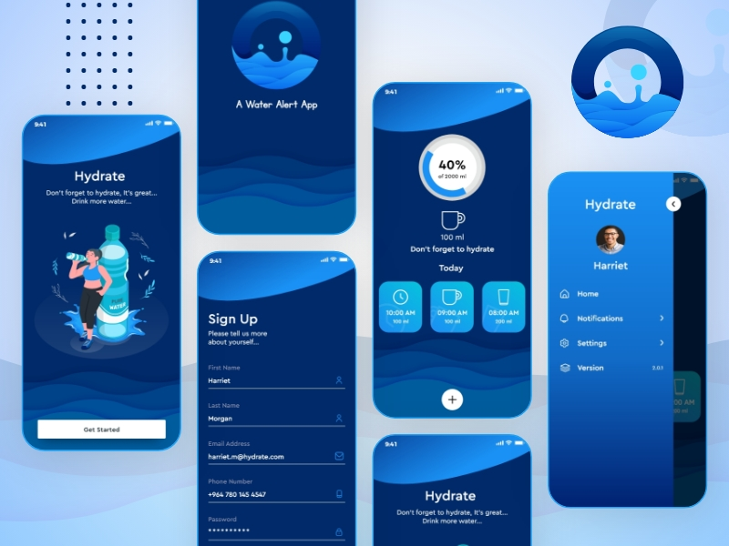

**Approval Signatures**

|  |
| --- |
|  |
| [Name], Student | |  | [Name], Instructor |
|  |  |  |  |